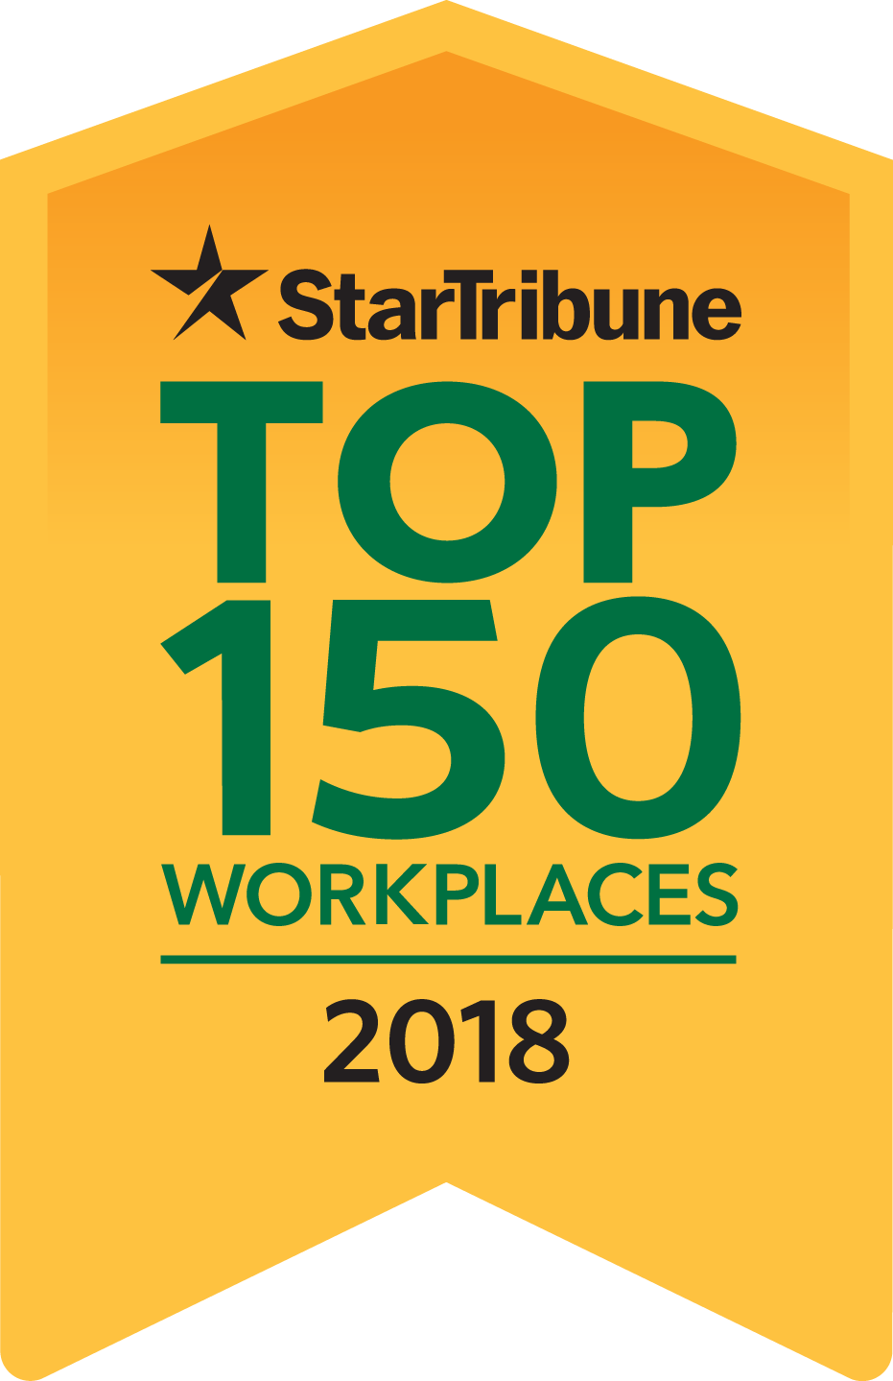

Star Tribune names
[your company’s name]
a 2018 Top 150 Workplace

[Name of city], MN [date], 2018—[your company’s name] has been named one of the Top 150 Workplaces in Minnesota by the Star Tribune. A complete list of those selected is available at StarTribune.com/topworkplaces2018 and will also be published in the Star Tribune Top Workplaces special section on Sunday, June 24.

Produced by the same team that compiles the 27-year-old Star Tribune 100 report of the best-performing public companies in Minnesota, Top Workplaces recognizes the most progressive companies in Minnesota based on employee opinions measuring engagement, organizational health and satisfaction. The analysis included responses from over 71,000 employees at Minnesota public, private and nonprofit organizations.

The rankings in the Star Tribune Top 150 Workplaces are based on survey information collected by Energage, formerly WorkplaceDynamics, an independent company specializing in employee engagement and retention.

[Your company’s name] was ranked [your company’s ranking] on the [large, midsize or small] company list.

[Quote from representative company]……………………………………

Star Tribune Publisher Michael J. Klingensmith said, “The companies in the
Star Tribune Top 150 Workplaces deserve high praise for creating the very best work environments in the state of Minnesota. My congratulations to each of these exceptional companies.”

[Additional information about company]
…………………………………

To qualify for the Star Tribune Top Workplaces, a company must have more than 50 employees in Minnesota. Over 2,400 companies were invited to participate. Rankings were composite scores calculated purely on the basis of employee responses.

