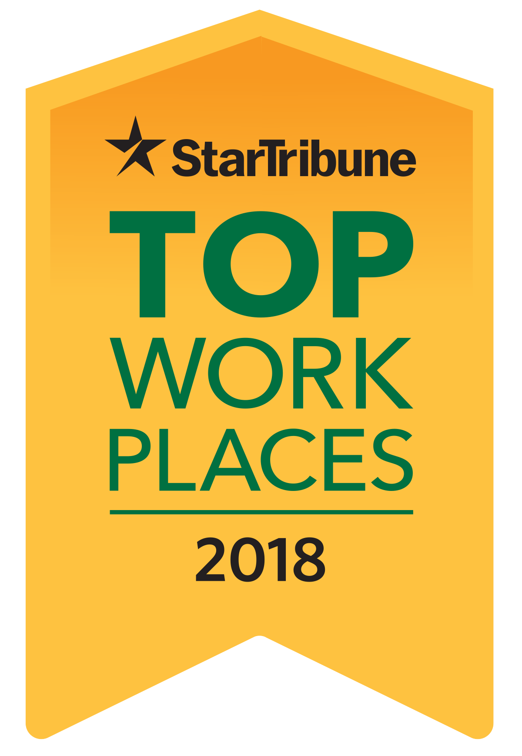

I am delighted to let you know that [your company’s name] has been recognized as a national standard Top Workplace. Among the many hundreds of employers that participated in this rigorous program, it is an honor to be placed in this category.

On the afternoon of Wednesday, June 20 you will be able to see us named on StarTribune.com/topworkplaces2018, and on Sunday, June 24, we will be listed in the
Star Tribune special section “Top Workplaces 2018.”

The evaluation for the Top Workplaces program is based upon feedback from an employee survey that many of you completed a few months ago. We had [your company’s number of responses] complete the survey, so thank you all for taking the time to respond.

Over 2,400 organizations were invited to participate in the survey, and over 71,000 employees shared their views. We are honored to be included in the list of Top Workplaces. Especially since the judges were you, our employees!

